Welcome to
High Lane Primary School

A Parents’ Guide to Starting Nursery

We are delighted to welcome you to our rather special High Lane community. We appreciate that when your child starts school, its paperwork galore and information overload. Don’t panic or feel the need to memorise everything - just keep this booklet handy to refer to when needed.

What is important to us at High Lane Primary School?
Our core values are the building blocks of life at High Lane and guide how we learn and behave. Our aim is that all children leave High Lane with a strong grounding in our core values and a commitment to applying them in their future lives.
Belonging | We value everyone's place in our school community
Relationships | We build positive relationships, show compassion and have trust in each other.
Respect | We respect ourselves, each other and our environment.
Curiosity | We ignite curiosity through engaging experiences which inspire creative thinking.
Resilience | We have the courage and determination to approach challenge positively.
Lifelong Learning | We nurture citizens of the future who feel empowered to strive for success, who dare to dream and reach their goals.

Starting School

Autumn Term 2023 starts on Wednesday 6th September 2023. We ask that for the first two weeks to support children in settling in that Nursery children do not arrive until 9:15am. Miss Johnstone will be available on the playground on the first week from 9:10am.

From week beginning Monday 18th September, we ask that you drop your child off at Nursery between 8:50am and 9:00am.

If you feel your child would benefit from a staggered start during the first two weeks, please let us know before Wednesday 6th September 2023.

How do I make changes to my child’s Nursery hours?

At High Lane Primary School, we offer morning sessions (9:00am to 12:00pm), afternoon sessions (1:00pm – 3:15pm) and full days (9:00am to 3:15pm). We appreciate that the number of hours you wish for your child to be in Nursery may change. In order for us to ensure we have appropriate staffing ratios, any requests to change your child’s initial allocated Nursery hours need to be sent in a written letter or email to our office team. Where possible, changes will be made and confirmed to you in writing. If you have any questions about Nursery hours, please contact the office:

Telephone: 01663 762378

Email: admin@highlane.stockport.sch.uk

Who’s who?

In time you will get to know the names and faces of all of our lovely members of staff, but let’s keep it straightforward for now:

Mrs Humphries  Headteacher |  | Miss Roper  Deputy Headteacher and Early Years Leader
Miss Lloyd  SENDCo |  | Miss Johnstone  EYFS Class Teacher
Mrs Yasmin  EYFS Teaching Assistant | Mrs Callaghan  EYFS HLTA and Teaching Assistant | Mrs Jones  EYFS Teaching Assistant
How do we support your child’s start at Nursery?

The first core principle of the Early Years Foundation Stage (EYFS) is that all children are unique. At High Lane Primary School, we are passionate about providing a quality transition process to fully ensure we are ready to welcome YOUR unique child. You can read more about our process below.

Nursery visits
During the term prior to your child starting Nursery, Miss Johnstone will make contact with your child’s Nursery or childminder to arrange a visit or a conversation with your child’s key worker/childminder. If you child has not attended another Nursery setting or childminder before, please do not worry, we will start our process by talking with you. This is the first step in building positive relationships – the second core principle of the EYFS.
Nursery Welcome Pack
The ‘Nursery Welcome Pack’ allows you to become a little more familiar with the faces of key staff members as well as starting to get to know what the EYFS is all about. There is also information about what to do if you have concerns around your child’s development.
Taster Session: Monday 24th July 2:00pm to 3:00pm
You and your child are invited to High Lane Primary School for an hour during our school day so the children can familiarise themselves with their teacher and peers. Please arrive at the school office to sign in for the taster session.

Home Visits/Telephone Calls
Home visits or telephone calls are an important part of the transition process and allow us to gain the information we need in order to make our environment welcoming and engaging for your child – the third core principle of the EYFS. We truly appreciate your support in allowing these home visits or telephone calls to happen. We will contact you to arrange a day and time that is suitable for you.

One Page Profiles
We feel it is important to get to know your children’s strengths, interests and areas where they may need more support. We also know that you will have lots of ways of supporting your child at home that would be helpful for us to know when supporting them in school. Our ‘One Page Profile’ is a place we can put all of this together and is a document that is revisited throughout the year as the children develop.

Class Dojo
Once you have signed the forms, you will have access to Class Dojo where we will post pictures and videos of the EYFS environment before your child starts for you to use to talk to your child about their first day in Nursery. Miss Johnstone will also post videos to start to reassure both you and your child before their first day.

What do we hope to provide for our children in our EYFS at High Lane Primary School?

The Early Years Curriculum at High Lane aims to provide children with meaningful experiences and the foundations for their educational journey. We strive to embed the school's core values, through the seven areas of learning from the EYFS Statutory Framework.
We provide a nurturing learning environment that fosters positive relationships and values the whole child, including their starting points, interests and individual rates of development. Through a carefully planned balance of play-based exploration and teacher-led activities, our children develop the characteristics of effective learning to become curious, confident, independent and active learners who reach their full potential and love learning. We believe that children’s well-being and mental health is central to their growth and development. Therefore, through a safe, caring, encouraging environment, we support our learners in developing a ‘have a go’ attitude, self-regulation and self-belief and pride in their own thinking, decision making and achievements. Reception and Nursery aged children work closely together, supporting each other in their learning adventures and regularly use our beautiful school grounds to explore nature and further develop through outdoor learning experiences. By providing enriching learning experiences, working collaboratively with parents and carers, and developing early skills to become capable lifelong learners, our children engage in a broad and balanced start to their learning journey.

Our EYFS curriculum aims to enable our children to be:

- Creative, capable and proud learners who are curious and make connections about the world around them.
- Secure, confident and resilient individuals who enjoy coming to school and have the self-regulatory skills to thrive when learning new knowledge and skills that develop from their existing learning.
- Increasingly focused and reflective problem solvers who have confidence in and can adapt their own decision making.
- Skilful communicators and collaborators who connect with others through language and play.
- Inquisitive and efficient early readers with an interest in rhythm, rhyme, sounds, shapes, letters and words through our bespoke High Lane phonics programme.

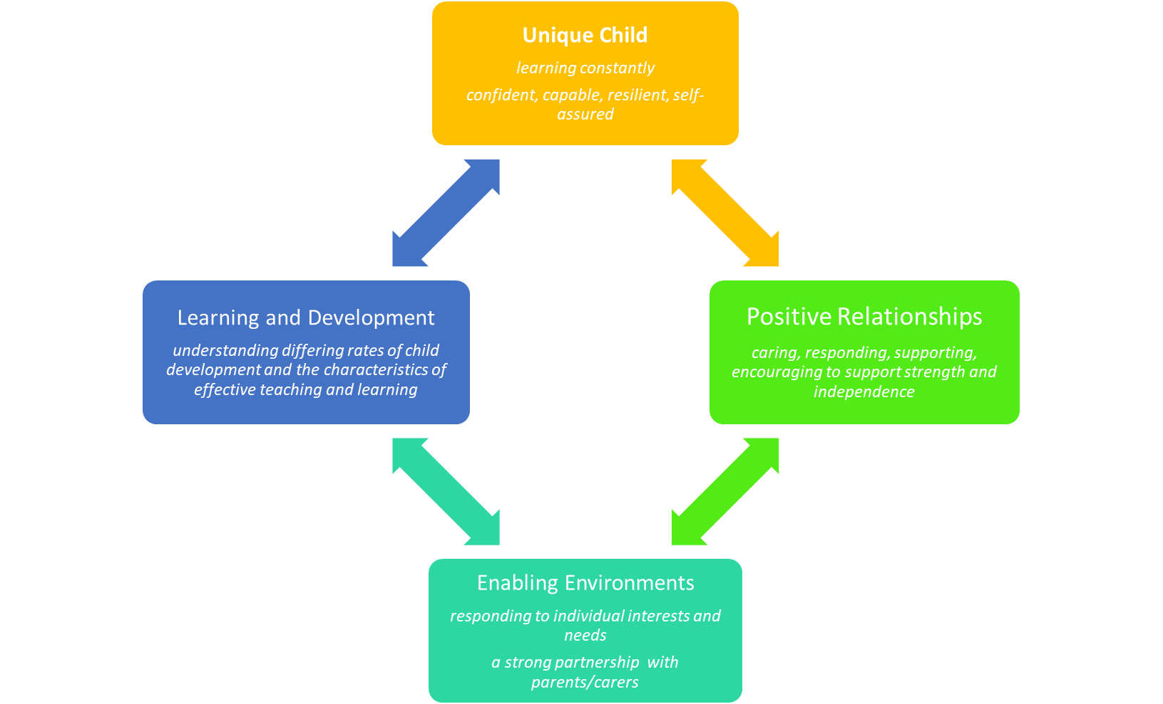
At High Lane Primary School, we follow the Early Years Foundation Stage framework and our practice is built upon the four principles within this framework:

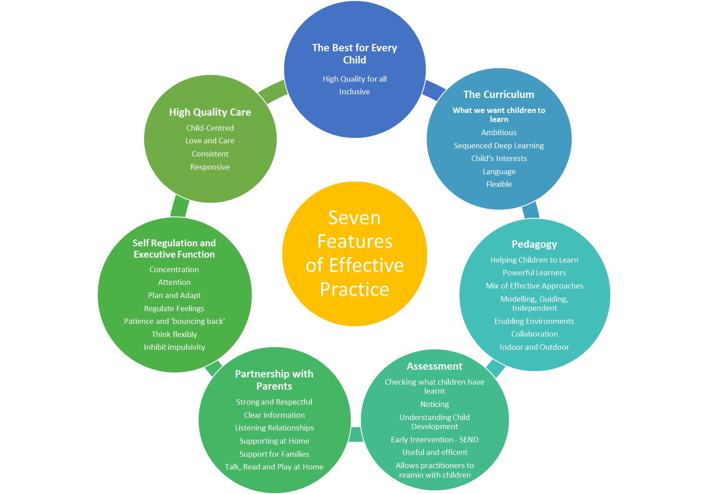
Children in both Nursery and Reception are provided with many learning opportunities accessible in our indoor and outdoor provision. They engage in planned, focused activities as well as self-initiated and free flow activities with the key features of effective practice embedded throughout:
Our carefully planned and sequenced curriculum provides a play-based and experiential learning environment, combined with focused teaching and basic skills, to ensure children make rapid progress and reach their potential before moving into Reception.
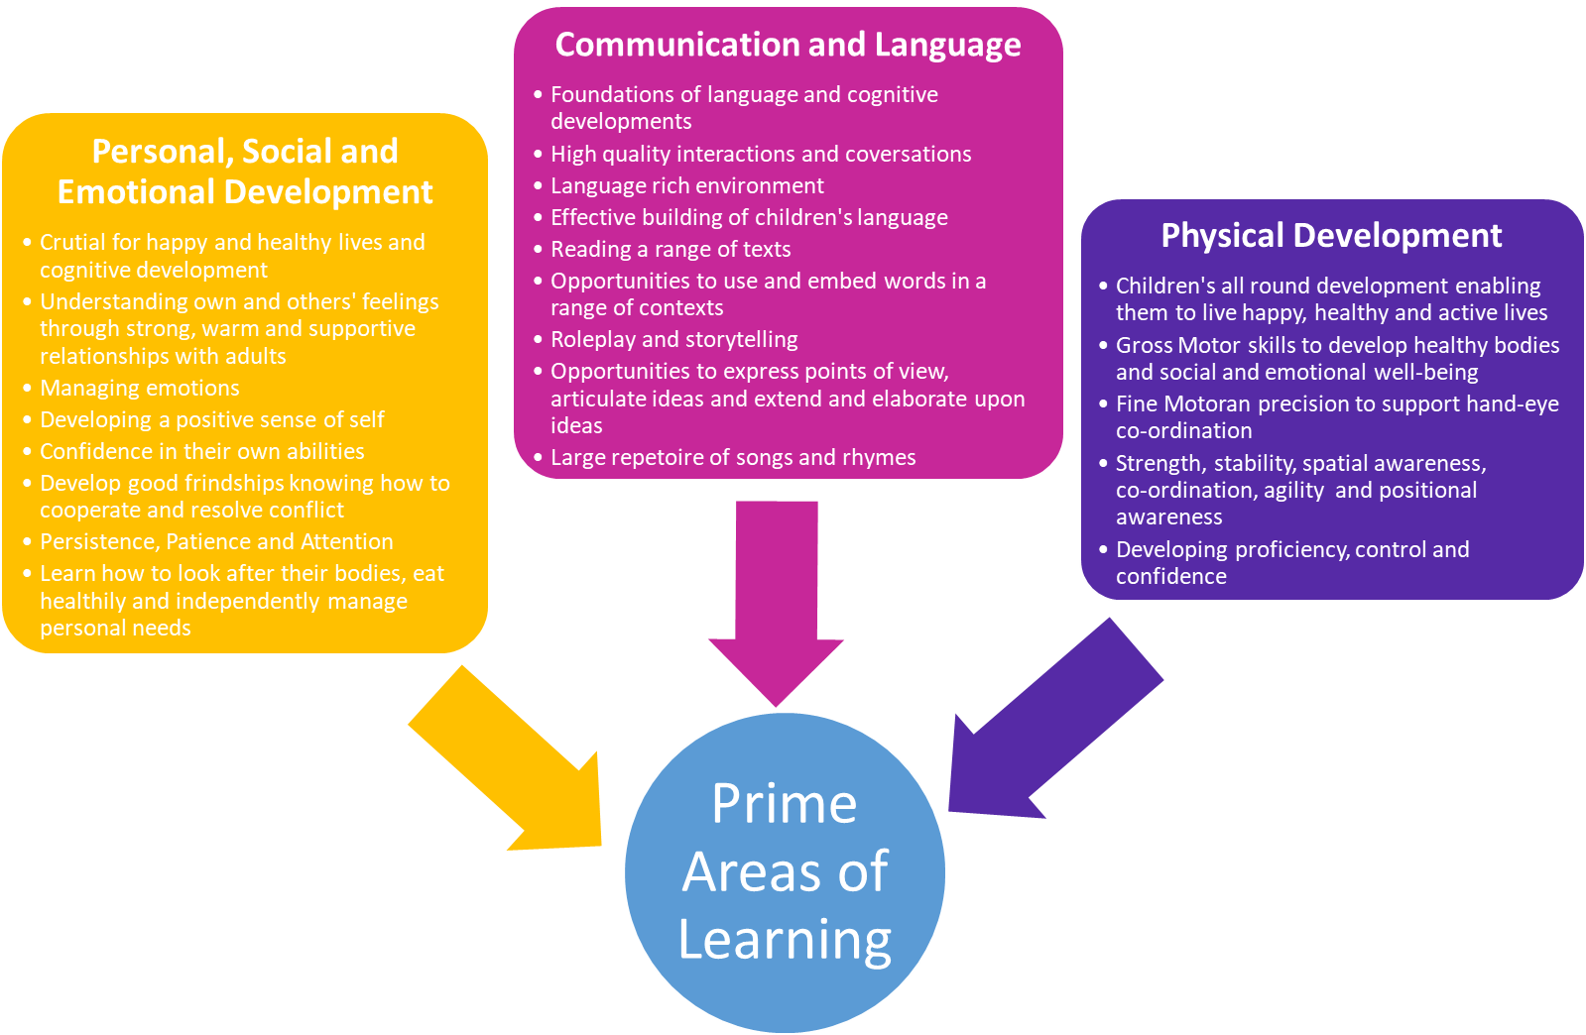
The learning experiences within our Early Years environment are driven by the seven areas of learning and development of EYFS Framework and Development Matters. These areas are split into three prime areas and four specific areas.
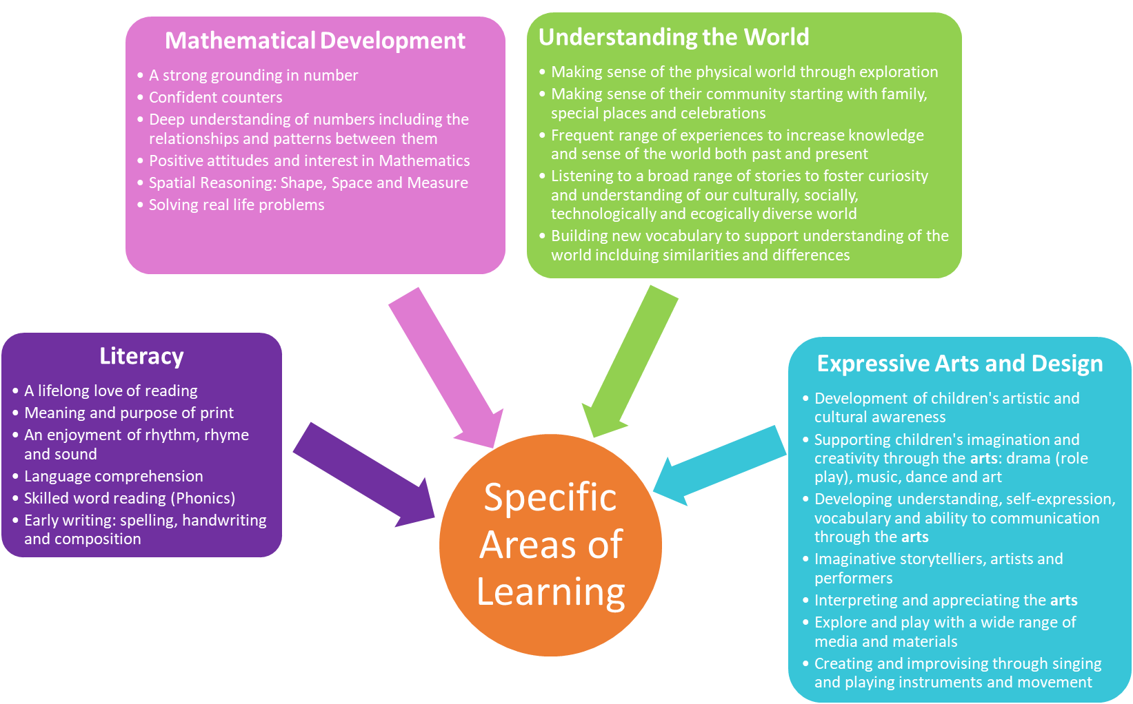
The learning experiences within our Early Years environment are driven by the seven areas of learning and development of EYFS Framework and Development Matters. These areas are split into three prime areas and four specific areas.
Children in both Nursery and Reception are provided with many learning opportunities accessible in our indoor and outdoor provision. They engage in planned, focused activities as well as self-initiated and free flow activities with the key features of effective practice embedded throughout:
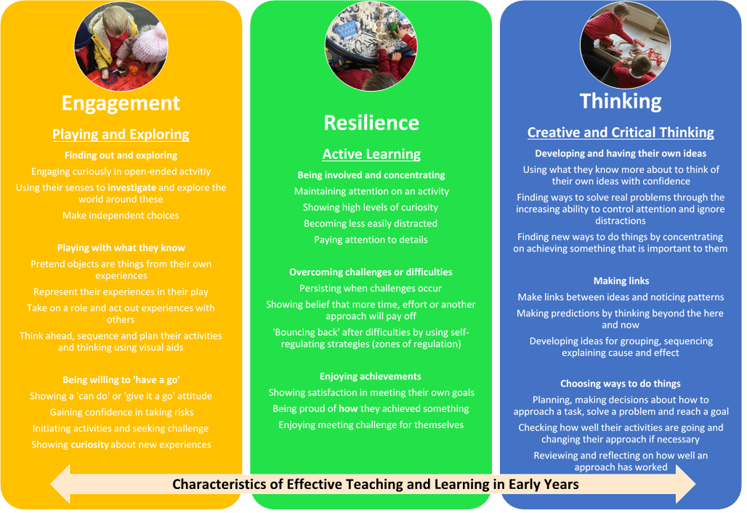
We strongly believe that in order for our children to develop their knowledge, skills and understanding in these seven areas of learning and as they move into Year 1 and beyond, they need to develop the following positive and effective learning behaviours which are based upon the 'Characteristics of Effective Teaching and Learning':
What can I do to support my child before they start at Nursery?

Firstly, talk about Nursery.
We understand this is a huge milestone in your child’s life. It’s perfectly normal for both you and your child to feel excited, anxious, and often a mixture of the two. Talk about Nursery positively, revisit the children’s welcome booklet and our Nursery Class Dojo Page often in the lead up to your child’s first day, and if you have any questions in the meantime, please feel free to get in touch through private message on Class Dojo or via the school’s telephone or email or even drop by to visit our team in our school office. No question is a silly question.

Secondly, encourage your child to be independent.
Independence breeds confidence and is an essential value for lifelong learners. There are always supportive adults on hand to help your child with whatever they need, but throughout the summer you may like to help your child practise skills to develop independence in: managing zips and buttons on clothes; putting on and fastening shoes on the right feet; eating with a knife and fork; using a tissue; and going to the toilet. It is important to let us know if there are any aspects that your child may need support with in their first few weeks so we can tailor our support for them to have the most positive start.

Finally, but perhaps most importantly; PLAY, PLAY, PLAY!
We follow a play-based curriculum in Nursery as this is how our youngest people learn best. We wholeheartedly promise that we can and will teach your child the foundations of reading, writing and solving mathematical problems. But, before reading comes singing Nursery rhymes, sharing stories with grown-ups and developing a love of books. Before writing comes lots of physical exercise to prepare our bodies for the physical act of writing. Before arithmetic comes a deep understanding of numbers: what they are, how to represent them with objects and symbols and how they relate to each other. All of this is achieved through play, where children don’t even realise they are learning because they are having too much fun.

How is a typical day in Nursery structured?

8.40 | Playground gates open.
8.58 | Miss Johnstone will be on the playground ready to greet your child. A whistle blows and the children line up to be taken into the EYFS classroom.
9.00 | Register and a short adult-led session around the day of a week, our weekly rhyme and a ‘check-in’ to understand how each child is feeling at the start of the day.
9:15 | Learning Time in Continuous Provision. This is child-led learning, where the children can follow their interests and explore the indoor and outdoor environment. Adults may lead group activities or model or observe in provision.
10:15 | Super Six Shared Reading: Each week the children get to know a high quality text focusing on book talk using our school ‘VIPERS’
10:30 | Snack Time: Children are offered milk, water and fruit
10:45 | Break Time
11.00 | Adult-led session focused on Mathematical Development
11.10 | Learning Time in Continuous Provision with short adult led mathematical activities
11:50 | Lunchtime: Children go into the dinner hall before having playtime in their EYFS outdoor area.
1:00 | Register
1:05 | Adult Led Phonics Session
1.20 | Learning Time in Continuous Provision
3:00 | Story Time
3.15 | Children are dismissed from the EYFS door to parents who will be waiting on the playground.

We will have class PE sessions twice a week. Through these sessions the children will have the opportunity to work independently and collaboratively, use different pieces of equipment and develop fine and gross motor skills. On PE days, children come into school in their PE kits.
We have a ‘Woodland Wednesday’ session once a week where the children spend the morning outdoors on our school field exploring and learning in nature. We are privileged to have such beautiful grounds to carry out these sessions. We have splash suits to support use in exploring the outdoors in all areas but do ask that your child has a change of clothes on these days.
Information about which days are PE days and when PE and Woodland Wednesday will begin will be shared on our Class Dojo Page.

Uniform and Equipment
Nursery children can wear their own clothes or school uniform each day. If you wish for your child to wear uniform, please see the information below.

Our full uniform policy is available on the school website, but below is a quick overview of everything you will need to start with.
Daily uniform
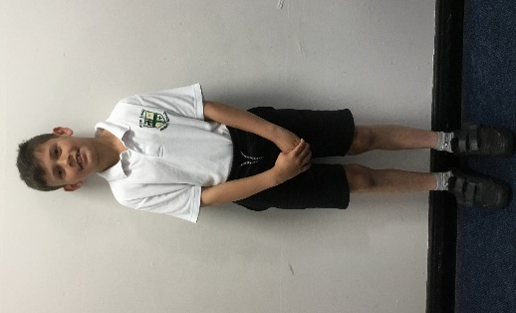 | 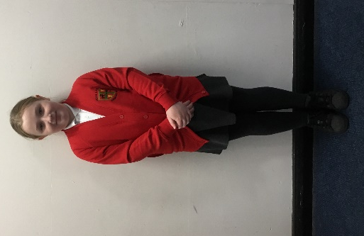 | 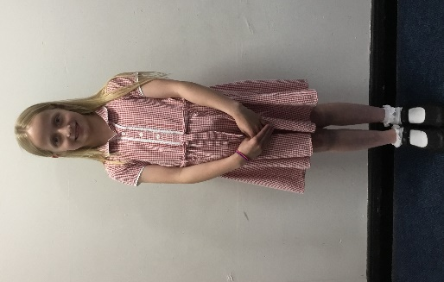
Cardigan with or without school logo; white polo shirt; grey pinafore or skirt; black, grey or red tights; black school shoes
OR

V-neck jumper with or without school logo; white polo shirt; grey trousers; grey socks and black school shoes

During the summer, a red checked dress with white socks, or grey shorts with grey socks can be worn.

Your child will also need a warm, waterproof coat and a pair of wellies to be kept in school. We ask that children dress for the weather as the children will ALWAYS have access to the outdoor area during their child-led learning. Please use your own judgement to decide each day if your child will need a hat, scarf and gloves or a sunhat.
PE Kit (to be worn on PE days)

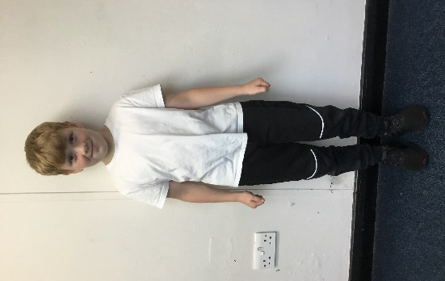
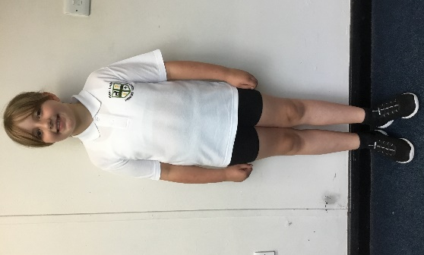

White polo shirt with or without school logo, black shorts or jogging bottoms, black plimsolls or trainers and white socks.
Uniform with the school logo can be ordered from the school office. Pre-loved uniform is also available throughout the school year.
We do have plenty of spare clothes in school but you may wish to provide your own spare set to be kept in school in case of accidents. Please make sure all uniform is labelled with your child’s name – including socks and shoes!
If you wish to make an order for school uniform please email admin@highlane.stockport.sch.uk with your child’s name, class, item, size and quantity you wish to order.

Uniform
White Polo Shirt with motif @ £9.75 each
Size:3 / 4 5/6 7/8 9/10 11/12 13
White T Shirt with motif @ £8.50 each
Size: 3/4 5/6 7/8 9/10 11/12 13
Red Sweatshirt @ £14.00 each
Size: 3 / 4 5/6 7/8 9/10 11/12 13
Red Sweatshirt Adult Size @ £18.00 each
Size: S, M, L, XL
Red Cardigan @ £15.00 each
Size: 3 / 4 5/6 7/8 9/10 11/12 13
Red Cardigan Adult Size @ £18.00 each
Size: S, M, L, XL
Pumpbag with High Lane crest @ £5.00 each
Bookbags @ £6.50 each
Water Bottles with High Lane crest @ £3.00 each

Payments can be made to
High Lane Primary School Fund
Account Number: 009 784 67 Sort Code: 30-98-12
Equipment

A bag to carry, for example, reading books or letters, and a water bottle.
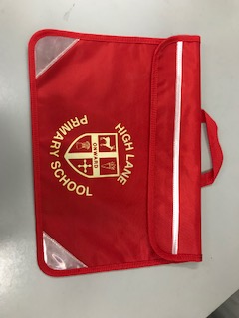
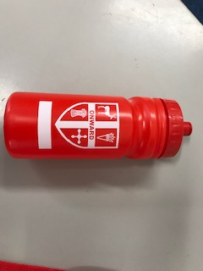

FAQs
Where can I park?
As a school, we encourage families to take as active a journey to school as possible. We appreciate that sometimes you will need to drive, so we politely request that you park responsibility, thinking about children’s safety and not blocking neighbours’ driveways. The school car park is strictly for staff and those with special exceptional circumstances, which have been agreed with the Headteacher.

Do you provide wrap-around care?
Marple Childcare provides breakfast club from 7:30am and afterschool club until 6pm and 5:30pm on Fridays at High Lane Primary School. If you require any further information please contact Marple Childcare on 07586 590886 or visit the school’s website.

How do I arrange for my child to have hot school lunches?
School Meals at High Lane Primary School are provided by Totally Local. Please use the information in your welcome pack to register for a Parent Pay account, through which you can view the menu, make a selection and pay for your child’s meal. It is often beneficial for your child to be part of selecting menu choices so that they know what they are expecting each day. If your child has a food intolerance/allergy contact the school office as soon as possible.

What if I’d like my child to have a packed lunch?
We ask that parents provide a healthy and balanced lunch to meet your child’s nutritional needs. Please do not include sweets, chocolate, ring-pull tins, cocktail or kebab sticks. It is pertinent that all food does not contain nuts or sesame of any kind, as we do have children who have severe allergies.

What do I do if my child takes prescribed medicine?
Medicine which your child may need during the day must be clearly labelled with your child’s name. It must be brought to the school office by an adult, where you will be given a detailed ‘administration of medicines form’ to complete. The Council Policy is that non-prescribed medication is not given by school except in the case of allergy medication. We will inform you if they have used it during the day. If your child has a more serious or long-term medical condition such as a nut allergy or asthma, please ask for a health care plan which we need you to complete so that we have all relevant details about medication and care of your child. If your child is prescribed antibiotics, the Council Policy is that we can only administer these in school if they are to be taken four times a day.
What is the process if my child is unwell?
If your child is too poorly to attend school, please telephone the office on the first day of their absence. If your child has sickness and/or diarrhoea, they must be clear of symptoms for 48 hours before returning to school.
What if my child has an appointment during school hours?
Please email the office to inform us about the absence so this can be recorded on our register. Please collect and/or drop off your child at the school office.

What do I do if I have any concerns about my child/their development?
- Talk to or arrange a meeting with the class teacher, Miss Johnstone
- Arrange a meeting with the EYFS Leader, Miss Roper
- Arrange a meeting with our SENDCo, Miss Lloyd
- Arrange a meeting with our Headteacher, Mrs Humphries

You can message all of the staff above through private Class Dojo message. You can also contact the school’s office via telephone to arrange a telephone or face to face appointment: 01663 762378

How can I keep up to date with school information?
We have several lines of communication to keep in touch with parents:
- Class Dojo: Whole School Story and Class Story
- ParentMail: A termly newsletter from the Headteacher, termly dates/events and information about what learning is happening in the classroom along with any specific letters around trips, visits or events
- School Website: Holiday dates, policies, information about our curriculum

Please check Class Dojo regularly and read emails through ParentMail carefully to ensure you don’t miss important information.
Can parents volunteer to help at school?
Yes. Please contact the office to learn about our volunteer training and process.

What do I need to do before my child starts?

- Complete the one page profile and return to school on one of the taster session.

- Attend the taster session on Monday 24th July 2023 between 2:00pm and 3:00pm. Your child’s EYFS teacher, Miss Johnstone; EYFS leader, Miss Roper; and the Headteacher, Mrs Humphries will be available at the end of the session should you have any questions.

- Return all forms in your welcome pack to allow us to keep you fully updated including on Class Dojo by 24th July 2023.

- Bring in or send us (Class Dojo) a family picture for our first Autumn theme by 24th July.

- Check Class Dojo for updates and videos to support your child’s transition and what to do on the first day of school.

- Let us know before your child’s first day if your child would benefit from a staggered start.

- Share the school dinner menu with your child and choose their meals together ensuring you order these the week before the first week at school.

- If you wish for your child to wear a school uniform, buy your child’s uniform – if you want items with the school logo, make sure you order this in plenty of time from the school office.

- ENJOY THE SUMMER! We look forward to welcoming you again in September.

Contact details

Address:
High Lane Primary School
Andrew Lane
High Lane
Stockport
SK6 8JQ

Telephone: 01663 762378

Email: For general enquiries: admin@highlane.stockport.sch.uk
For formal correspondence: headteacher@highlane.stockport.sch.uk

